Supplementary Methods
Discovery cohort sampling rationale
The discovery cohort was selected from the Longitudinal Assessment of Bariatric Surgery-2 (LABS-2) cohort, a prospective, multicentre observational study of adults undergoing bariatric surgery in routine clinical care. For the present analysis, we focused on participants who underwent Roux-en-Y gastric bypass (RYGB) and had longitudinal weight data through seven years of follow-up.
Because untargeted metabolomic profiling remains resource-intensive and this was a discovery-phase investigation, we used an extreme-phenotype sampling strategy. Participants were selected from the two most divergent long-term weight trajectory classes: sustained weight loss and substantial weight regain. This design maximises phenotypic contrast and improves efficiency for biomarker discovery when whole-cohort profiling is not feasible. The design is intended for hypothesis generation and biological discovery rather than definitive estimation of predictive performance in an unselected surgical population.
The metabolomic discovery subset included 80 matched pairs. The sample size was selected to provide adequate power to detect moderate metabolite effect sizes in a matched-pair design. For an anticipated Cohen’s d of approximately 0.5 and α=0.05, 80 matched pairs provide approximately 86% power. The ratio of observations to prescreened candidate metabolites was considered appropriate for penalised and stepwise multivariable modelling followed by internal validation, recognising the exploratory nature of the analysis.
Latent class growth mixture modelling
Longitudinal excess body weight trajectories were modelled using latent class growth mixture modelling in Mplus version 7.4. Excess body weight was defined as measured body weight minus ideal body weight corresponding to a body mass index of 25 kg/m². Models were estimated using robust maximum likelihood with 500 initial and 50 final random starts to reduce the risk of convergence to local maxima.
Candidate models with two, three, four, and five latent classes were evaluated. Model selection considered the Bayesian Information Criterion, sample-size-adjusted Bayesian Information Criterion, Vuong-Lo-Mendell-Rubin likelihood ratio test, bootstrap likelihood ratio test, entropy, posterior class membership probabilities, class size, and clinical interpretability. The three-class solution was selected because it provided the best balance of statistical fit, classification certainty, clinically meaningful class sizes, and trajectory patterns that mapped onto prespecified phenotypes of interest. Mean posterior class membership probabilities exceeded 0.90 for all three classes, indicating high classification certainty.
Classes representing sustained weight loss and substantial weight regain were selected for metabolomic profiling because they had comparable baseline excess body weight but divergent long-term trajectories. The third class was not selected because its substantially lower baseline excess body weight would have made metabolite comparisons more difficult to interpret, potentially reflecting baseline adiposity rather than trajectory-specific biology.
Propensity score matching
Participants in the sustained weight-loss group were matched 1:1 to participants in the weight-regain group using propensity scores. Propensity scores were estimated using logistic regression with trajectory group as the outcome and baseline age, sex, body mass index, race, and estimated glomerular filtration rate as predictors. Matching was performed using nearest-neighbour matching without replacement and a caliper width of 0.2 standard deviations of the logit of the propensity score. Balance was assessed using standardised mean differences, with values less than 0.10 considered acceptable. Matching was performed using the MatchIt package in R version 4.5.0.
Broken-stick modelling of weight trajectories
Non-linear excess body weight trajectories were modelled using the brokenstick package in R version 2.7.0. The broken-stick model uses linear B-splines to represent non-linear change over time while preserving interpretability. Knots were placed at 6, 12, and 24 months to capture clinically recognised phases of post-RYGB weight change: rapid early weight loss from 0 to 6 months, continued weight loss with decelerating slope from 6 to 12 months, nadir and stabilisation from 12 to 24 months, and subsequent long-term trajectory from 24 to 84 months.
The model included time as the fixed-effects predictor and excess body weight as the outcome, with participant-specific random intercepts and slopes at each knot. Model fit was evaluated by comparison with simple linear regression and by visual inspection of observed and predicted trajectories. Predicted excess body weight values at fixed time points were used for downstream analyses to reduce variability due to differences in visit timing.
Metabolomic profiling platform
Preoperative fasting plasma samples from LABS-2 were processed within two hours of collection and stored at −80°C until analysis. Samples were randomised across analytical batches and interspersed with pooled quality-control samples. Plasma metabolite and lipid profiles were measured at the Broad Institute Metabolomics Platform using four complementary liquid chromatography–mass spectrometry methods.
HILIC positive ion mode
Hydrophilic interaction liquid chromatography analyses of water-soluble metabolites in positive ion mode were performed using a Shimadzu Nexera X2 ultra-high-performance liquid chromatography system coupled to a Q Exactive hybrid quadrupole orbitrap mass spectrometer. Plasma samples of 10 μL were prepared by protein precipitation with nine volumes of 74.9:24.9:0.2 v/v/v acetonitrile/methanol/formic acid containing stable isotope-labelled internal standards, including valine-d8 and phenylalanine-d8. Samples were centrifuged for 10 min at 9000g and 4°C, and supernatants were injected onto a 150 × 2 mm, 3 μm Atlantis HILIC column.
The column was eluted isocratically at 250 μL/min with 5% mobile phase A, consisting of 10 mmol/L ammonium formate and 0.1% formic acid in water, for 0.5 min, followed by a linear gradient to 40% mobile phase B, consisting of acetonitrile with 0.1% formic acid, over 10 min. Mass spectrometry was performed using electrospray ionisation in positive ion mode with full-scan acquisition over m/z 70–800 at 70,000 resolution and 3 Hz acquisition rate. Additional settings included sheath gas 40, sweep gas 2, spray voltage 3.5 kV, capillary temperature 350°C, S-lens RF 40, heater temperature 300°C, microscans 1, automatic gain control target 1e6, and maximum ion time 250 ms.
HILIC negative ion mode
Hydrophilic interaction liquid chromatography analyses of water-soluble metabolites in negative ion mode were performed using a Shimadzu Nexera X2 ultra-high-performance liquid chromatography system coupled to a Q Exactive Plus mass spectrometer. Metabolites were extracted from 30 μL plasma using 120 μL of 80% methanol containing inosine-15N4, thymine-d4, and glycocholate-d4 internal standards. Samples were centrifuged for 10 min at 9000g and 4°C, and supernatants were injected onto a 150 × 2.0 mm Luna NH2 column.
The column was eluted at 400 μL/min with initial conditions of 10% mobile phase A, consisting of 20 mmol/L ammonium acetate and 20 mmol/L ammonium hydroxide in water, and 90% mobile phase B, consisting of 10 mmol/L ammonium hydroxide in 75:25 v/v acetonitrile/methanol, followed by a 10 min linear gradient to 100% mobile phase A. Mass spectrometry was performed using electrospray ionisation in negative ion mode with full-scan acquisition over m/z 70–750 at 70,000 resolution and 3 Hz acquisition rate. Additional settings included ion spray voltage −3.0 kV, capillary temperature 350°C, probe heater temperature 325°C, sheath gas 55, auxiliary gas 10, and S-lens RF level 50.
C18 reversed-phase negative ion mode
Reversed-phase C18 chromatography in negative ion mode was used to profile free fatty acids, bile acids, and metabolites of intermediate polarity. Analyses were performed using a Shimadzu Nexera X2 ultra-high-performance liquid chromatography system coupled to a Q Exactive hybrid quadrupole orbitrap mass spectrometer. Plasma samples of 30 μL were extracted using methanol containing 15R-15-methyl-PGA2, 15S-15-methyl-PGE1, and 15S-15-methyl-PGE2 internal standards. Supernatants were injected onto a 150 × 2.1 mm ACQUITY T3 column.
The column was eluted isocratically at 450 μL/min with 20% mobile phase A, consisting of 0.01% formic acid in water, for 3 min, followed by a linear gradient to 100% mobile phase B, consisting of 0.01% acetic acid in acetonitrile, over 12 min. Mass spectrometry was performed using electrospray ionisation in negative ion mode with full-scan acquisition over m/z 70–850 at 70,000 resolution and 3 Hz acquisition rate. Additional settings included ion spray voltage −3.5 kV, capillary temperature 320°C, probe heater temperature 300°C, sheath gas 45, auxiliary gas 10, and S-lens RF level 60.
C8 reversed-phase positive ion mode
Positive ion mode analyses of polar and non-polar plasma lipids were performed using C8 reversed-phase chromatography on a Shimadzu Nexera X2 ultra-high-performance liquid chromatography system coupled to an Exactive Plus orbitrap mass spectrometer. Plasma samples of 10 μL were extracted using 190 μL isopropanol containing 1,2-didodecanoyl-sn-glycero-3-phosphocholine as an internal standard. After centrifugation, supernatants were injected onto a 100 × 2.1 mm, 1.7 μm ACQUITY BEH C8 column.
The column was eluted isocratically with 80% mobile phase A, consisting of 95:5:0.1 v/v/v 10 mmol/L ammonium acetate/methanol/formic acid, for 1 min, followed by a linear gradient to 80% mobile phase B, consisting of 99.9:0.1 v/v methanol/formic acid, over 2 min, a linear gradient to 100% mobile phase B over 7 min, and 3 min at 100% mobile phase B. Mass spectrometry was performed using electrospray ionisation in positive ion mode with full-scan acquisition over m/z 220–1100 at 70,000 resolution and 3 Hz acquisition rate. Additional settings included sheath gas 50, in-source collision-induced dissociation 5 eV, sweep gas 5, spray voltage 3 kV, capillary temperature 300°C, S-lens RF 60, heater temperature 300°C, microscans 1, automatic gain control target 1e6, and maximum ion time 100 ms.
Metabolomics quality control and data processing
Data quality was assessed by monitoring internal standard performance in every sample and by regular analysis of pooled plasma quality-control samples. Pairs of pooled quality-control samples were analysed after approximately every 20 study samples. One pooled quality-control sample from each pair was used to correct for mass spectrometry sensitivity drift across the analytical run using nearest-neighbour scaling. The other pooled quality-control sample was used to calculate coefficients of variation for each metabolite and unknown feature as a measure of analytical precision.
Raw data were processed using TraceFinder version 3.3 and Progenesis QI. Metabolite identities in the HILIC positive, HILIC negative, and C18 negative methods were confirmed using authentic reference standards when available. Lipid identities were determined by comparison with standards representative of each lipid class and with reference plasma extracts. Lipid annotations were reported by total number of carbons and total number of double bonds in the lipid acyl chain or chains.
Metabolite annotation confidence followed Metabolomics Standards Initiative guidelines. Level 1 identifications were assigned when retention time, exact mass, and MS/MS fragmentation matched authentic standards. Structural isomers that co-eluted under the chromatographic conditions and shared identical molecular formulas were reported as slash-delimited composite annotations. One metabolite risk score feature was affected by this ambiguity: 3-methyladipate/pimelate, also annotated as 3-methylhexanedioic acid/heptanedioic acid, with shared molecular formula C₇H₁₂O₄ and exact monoisotopic mass 160.0736 Da in HILIC negative mode. For downstream SPOKE analysis, both candidate identities, HMDB0000555 and HMDB0000714, were retained as seed nodes to preserve the full biological neighbourhood of the ambiguous feature.
Metabolite profiling for LABS-2 and the post-RYGB clinical cohort used the same four-mode LC-MS platform. Across cohorts, this platform quantified approximately 370–560 metabolites, depending on sample set and analytical coverage. Of the 13 metabolites in the full metabolite risk score, 10 were quantifiable in the post-RYGB clinical cohort and eight were available in the Estonian Biobank dataset. Reduced scores were therefore calculated using available metabolites while retaining discovery-model coefficients.
Metabolomic preprocessing and imputation
Metabolite concentrations were log-transformed before covariate adjustment. In the discovery cohort, metabolite values were adjusted for relevant covariates, including age, sex, race, fasting time, baseline BMI, diabetes status, and smoking status. Where analogous variables were available, the same preprocessing framework was applied in external cohorts. Missing metabolite values were imputed using the MICE package version 3.1 with three imputations. The median value across imputations was used for downstream analyses to reduce stochastic variation across imputed datasets. Covariate-adjusted residuals were transformed using rank-based inverse normal transformation.
Metabolite risk score development
Metabolite association testing was first performed using linear regression to test associations between preprocessed metabolite residuals and five-year excess body weight change. A nominal p value threshold less than 0.05 was used to define candidate metabolites for multivariable modelling. Benjamini-Hochberg false discovery rate correction was applied to identify metabolites meeting multiple-testing-adjusted significance.
Candidate metabolites were entered into bidirectional stepwise linear regression, with model selection guided by Akaike Information Criterion. Adjusted R² was calculated post hoc to assess explanatory power. Correlation among candidate metabolites was evaluated before final model selection, and metabolite pairs with absolute Pearson correlation greater than 0.5 were reviewed to reduce redundancy. Variance inflation factors were calculated for retained metabolites, and residual diagnostics were examined to assess linearity, homoscedasticity, and normality.
The metabolite risk score was calculated for each participant as a weighted linear combination of standardised metabolite levels:
$$MetRS=\sum{Z_{i}β_{i}}$$
where $Z_{i}$ represents the standardised value of metabolite $i$ and $β_{i}$ represents the corresponding regression coefficient from the discovery model.
Conditional logistic regression was used to evaluate the metabolite risk score with clinical covariates, including age, sex, and baseline BMI. Model performance was assessed using repeated 10-fold cross-validation over 100 iterations. Discriminatory ability was quantified using the c-statistic, corresponding to the area under the receiver operating characteristic curve.
Bootstrap stability and sensitivity analyses
Variable-selection stability was assessed by bootstrap resampling. The bidirectional stepwise selection procedure was repeated in 1000 bootstrap-resampled datasets, with resampling performed at the matched-pair level to preserve the case-control structure. For each metabolite, selection frequency was calculated as the proportion of bootstrap iterations in which the metabolite was retained in the final model. Metabolites selected in more than 50% of bootstrap iterations were considered stable, and metabolites selected in more than 75% were considered to form a highly stable core signal.
As a sensitivity analysis, least absolute shrinkage and selection operator regression was performed using 10-fold cross-validation for λ selection and the one-standard-error rule. Overlap between metabolites selected by LASSO and those selected by the stepwise approach was evaluated. To assess the effect of cross-platform metabolite availability, reduced versions of the metabolite risk score were calculated in LABS-2 using only metabolites available in the external evaluation datasets. Pearson correlations between the full 13-metabolite score and the reduced scores were calculated, and discriminatory performance for weight-regain classification was compared using conditional logistic regression with cross-validation.
External evaluation of metabolite risk scores
Reduced metabolite risk scores were computed in the post-RYGB clinical cohort and the Estonian Biobank using coefficients from the LABS-2 discovery model, restricted to metabolites available in each dataset. The post-RYGB clinical cohort used a 10-metabolite reduced score, and the Estonian Biobank used an eight-metabolite reduced score.
In the post-RYGB clinical cohort, reduced scores were compared between participants with weight regain and sustained weight loss using t tests and were evaluated for association with degree of weight regain using linear regression. In the Estonian Biobank, reduced scores were compared between lean individuals and individuals with obesity. Because the Estonian Biobank cohort did not include bariatric surgery outcomes, this analysis was interpreted as an evaluation of obesity-related metabolic biology rather than validation of surgical outcome prediction.
SPOKE network analysis
Network analysis was performed using the Scalable Precision Medicine Open Knowledge Engine, a heterogeneous biomedical knowledge graph integrating compounds, genes, human proteins, Gene Ontology biological processes and molecular functions, WikiPathways, Reactome pathways, protein domains, and disease terms from Disease Ontology, with curated relationships drawn from more than 40 primary resources.
The analytical seed set consisted of the metabolite risk score components plus dimethylguanidino valeric acid. The composite 3-methyladipate/pimelate feature was represented by two candidate compound nodes because SPOKE retains separate entries for structural isomers. This yielded 15 analytical seed compounds, all of which were successfully mapped to SPOKE compound identifiers using HMDB cross-references.
Two complementary traversals were performed and combined into a curated subgraph. First, for each seed metabolite, curated first-degree neighbours were retrieved across gene, protein, biological process, molecular function, pathway, and disease nodes. Second, shortest paths of length five edges or fewer were extracted for each unordered seed-metabolite pair. Intermediate nodes were restricted to compound, gene, human protein, biological process, molecular function, pathway, disease, and protein domain nodes. Protein nodes were required to correspond to human proteins. Shortest-path extraction across all seed-metabolite pairs generated a Steiner-tree approximation of the shared biological context linking metabolite risk score components.
Each node in the resulting subgraph was characterised using degree, normalised betweenness centrality, and PageRank. Normalised betweenness centrality was used to identify bridge nodes connecting biological modules, because nodes with high betweenness lie on a disproportionate number of shortest paths between other nodes and may represent points of biological convergence. Network analysis was performed using igraph version 2.3.0 in R. Graph layout was computed using the Kamada-Kawai force-directed algorithm.
Biological modules were identified by inspection of subgraph topology, guided by shared connections among seed metabolites and by betweenness-ranked bridge nodes. Disease annotations were drawn from Disease Ontology terms indexed within SPOKE. Pathway and biological-process annotations were cross-referenced against WikiPathways, Gene Ontology, Reactome, and the Human Metabolome Database as integrated within the SPOKE knowledge graph.
Framingham Heart Study genotyping, imputation, and genome-wide association analyses
Framingham Heart Study data were obtained through dbGaP accession phs000007.v29.p10, consent group HMB-IRB-MDS. Genome-wide association analyses were performed in the Framingham Heart Study Offspring Cohort among participants with available fasting plasma metabolomic profiling and genotype data.
Genotype quality control included removal of participants with discordance between genetic and reported sex, samples with more than 2% missing variants, samples with extreme heterozygosity more than four standard deviations from the mean, and individuals with excessive genetic relatedness inconsistent with analysis requirements. Variant-level quality control excluded variants with minor allele frequency less than 1%, missingness greater than 5%, excessive plate effects, or deviation from Hardy-Weinberg equilibrium. Variant coordinates were aligned to hg19/GRCh37 using liftOver. Principal components analysis was performed using SMARTPCA, and samples were projected onto 1000 Genomes reference populations. Samples that did not cluster with the expected European ancestry reference population were excluded. Quality-control procedures were performed using PLINK version 1.07 and custom R and Perl scripts.
Genotype imputation was performed using the Michigan Imputation Server with the Haplotype Reference Consortium reference panel version r1.1 2016. Autosomal genome-wide association analyses were performed using SAIGE, which implements a linear mixed model suitable for cohorts with sample relatedness. X chromosome analyses were performed using PLINK 2.0 in unrelated participants.
Genome-wide association analyses were conducted for the metabolite risk score and for individual metabolite risk score components. Models were adjusted for age, sex, BMI, and ten genetic principal components. Genome-wide significance was defined as p less than 5 × 10⁻⁸. Independent genome-wide significant loci were identified using PLINK clumping with a 500 kb genomic window and linkage disequilibrium r² threshold of 0.1. For regions with more than one genome-wide significant signal, conditional analysis was performed recursively by adjusting for the top signal until only independent signals remained. Manhattan and quantile-quantile plots were generated in R. Regional association plots were generated using LocusZoom. Functional annotation of genome-wide significant loci was performed using BioThings.
Statistical software and reproducibility
All statistical analyses were performed using R version 4.0.3 unless otherwise specified. Matching was performed using MatchIt version 4.5.0. Broken-stick modelling used brokenstick version 2.7.0. Network analyses used igraph version 2.3.0. Heatmaps were generated using MetaboAnalyst version 5.0. Forest plots were generated using the forestplot package. Other figures were generated using ggplot2 version 4.0.3.
Random seeds were set at the start of analytical scripts for cross-validation, bootstrap resampling, and imputation. Seeds are documented in the deposited analysis code. Statistical parameters, including sample sizes, effect estimates, confidence intervals, and p values, are reported in the Results section, figure legends, and Supplementary Tables.
Supplementary Tables
Supplemental Table 1a. Baseline characteristics of the LABS-2 discovery cohort
Characteristic | Total (n=160) | Class 1 | Class 2 | p-value
 |  | Weight Regain (n = 80) | Sustained Weight Loss (n=80)
Female, n (%) | 70 (43.8%) | 35 (43.8%) | 35 (43.8%)
Age at surgery, years | 42.4 (9.9) | 42.3 (9.7) | 42.5 (10.2)
Race, n (%)
White | 123 (76.9%) | 63 (78.8%) | 60 (75.0%)
Black | 28 (17.5%) | 13 (16.3%) | 15 (18.8%)
Other | 8 (5.0%) | 4 (5.0%) | 4 (5.0%)
Weight, kg | 178.1 (22.9) | 181.2 (20.2) | 175.1 (25.1)
Height, cm | 173.4 (10.4) | 174.5 (9.8) | 172.2 (10.9)
BMI, kg/m2 | 59.3 (5.9) | 59.6 (5.7) | 59.0 (6.2)
Excess Body Weight, kg | 102.6 (18.1) | 104.6 (16.2) | 100.5 (19.7) | NS
Cholesterol, mg/dL | 175.7 (36.0) | 172.9 (34.8) | 178.6 (37.2)
HDL Cholesterol, mg/dL | 40.5 (9.5) | 40.7 (9.7) | 40.3 (9.2)
LDL Cholesterol, mg/dL | 104.8 (32.9) | 102.6 (30.3) | 107.0 (35.4)
Triglycerides, mg/dL | 154.0 (79.1) | 147.7 (65.7) | 160.4 (90.9)
Free Fatty Acids, mEq/L | 0.8 (0.3) | 0.7 (0.3) | 0.8 (0.3)
HbA1c, % | 6.0 (1.1) | 6.0 (1.0) | 5.9 (1.2)
Fasting Insulin, uIU/mL | 30.6 (26.2) | 30.9 (28.3) | 30.2 (24.1)
Proinsulin, pM | 38.4 (36.9) | 36.6 (32.0) | 40.2 (41.4)
C-peptide, ng/mL | 4.5 (1.6) | 4.4 (1.4) | 4.6 (1.8)
Leptin, ng/mL | 72.1 (25.3) | 68.2 (25.2) | 76.0 (24.9)
Ghrelin, pg/mL | 723.8 (273.7) | 711.3 (190.3) | 736.4 (338.6)
hsCRP, mg/dL | 1.3 (1.3) | 1.3 (1.6) | 1.4 (1.0)
Serum Creeatinine, mg/dL | 0.8 (0.3) | 0.8 (0.2) | 0.9 (0.4)
Supplemental Table 1b. Post-RYGB surgery cohort
Characteristic | Overall (n = 36) | Weight Regain (n= 21) | Sustained Weight Loss (n= 15) | p-value
Age | 45.6 (11.1) | 48.1 (10.9) | 42.1 (10.7) | 0.046
Female | 35 (97.2%) | 20 (95.2%) | 15 (100.0%) | NS
Race/ethnicity |  |  |  | NS
White | 20 (55.6%) | 10 (47.6%) | 10 (66.7%)
Hispanic | 11 (30.6%) | 8 (38.1%) | 3 (20.0%)
Black | 3 (8.3%) | 2 (9.5%) | 1 (6.7%)
Other | 2 (5.6%) | 1 (6.7%) | 1 (6.7%)
Height, cm | 164.6 (6.2) | 164.4 (7.4) | 165.1 (5.1) | NS
Current.Weight, kg | 93.5 (20.6) | 101.5 (20.2) | 82.3 (15.6) | 0.006
BMI, kg/m2 | 34.6 (6.7) | 37.8 (5.8) | 30.2 (5.2) | <0.001
Hypertension | 8 (22%) | 6 (28.5%) | 2 (13%) | NS
Type 2 diabetes | 5 (13.9%) | 4 (19%) | 1 ( 6.7%) | NS
Hyperlipidemia | 8 (22%) | 6 (28.5%) | 2 (13%) | NS
Coronary artery disease | 0 (%) | 0 (%) | 0 (%) | >0.999
Years since surgery | 7.4 (3.8) | 8.9 (3.0) | 5.3 (3.7) | 0.006
Pre-surgery weight, kg | 133.6 (26.8) | 135.0 (28.8) | 131.7 (24.5) | NS
PreSurgery BMI, kg/m2 | 49.1 (7.8) | 49.6 (7.4) | 48.3 (8.6) | NS
Weight loss, kg | 55.5 (20.8) | 56.7 (22.3) | 53.9 (19.1) | NS
Weight regain, kg | 15.4 (13.3) | 23.3 (11.2) | 4.5 (6.5) | <0.001
Weight regain, % | 27.5 (21.9) | 42.1 (15.3) | 7.1 (9.8) | <0.001
Excess body weight, kg | 73.0 (24.5) | 74.4 (25.4) | 71.0 (23.9) | NS
Excess weight loss, % | 77.3 (14.7) | 76.5 (10.7) | 78.5 (19.3) | NS
Ideal body weight, kg | 60.6 (3.7) | 60.6 (4.4) | 60.7 (2.7) | NS
Supplemental Table 1c. Estonia Biobank, Obesity Extremes cohort
Characteristic | Total (n=198) | Lean (n=98) | Obese (n=100)
Sex, n (%)
Female | 99 (50.0%) | 49 (50.0%) | 50 (50.0%)
Age, years | 37.0 (11.7) | 36.7 (11.7) | 37.2 (11.8)
BMI, kg/m² | 29.4 (11.5) | 18.0 (1.1) | 40.5 (4.8)
Fasting time, hours | 8.1 (3.5) | 8.0 (3.4) | 8.2 (3.6)

Supplemental Table 2. Prioritized metabolites for MetRS
Metabolites | Estimate | Std.error | Statistic | P.value | Chemical_name | HMDB_ID | Subclass | Direct_parent
adonitol_arabitol | -0.06045 | 0.019005 | -3.18076 | 0.001768 | adonitol; L-arabitol | HMDB0000508; HMDB0001851 | Sugar alcohols; Sugar alcohols | Sugar alcohols; Sugar alcohols
alpha_cehc | 0.045722 | 0.019263 | 2.373533 | 0.018821 | alpha-CEHC | HMDB0001518 | Chromans | Chromans
arachidate | -0.046281 | 0.019255 | -2.403593 | 0.017393 | arachidic acid | HMDB0002212 | Long-chain fatty acids | Straight chain fatty acids
bilirubin | 0.05666 | 0.019079 | 2.96982 | 0.003445 | bilirubin | HMDB0000054 | Bilirubins | Bilirubins
c18_0_lpc | -0.047326 | 0.019239 | -2.459935 | 0.014974 | LPC(18:0) |  | Glycerophosphocholines | Lysophosphatidylcholines
c18_1_lpc | -0.039944 | 0.019345 | -2.06485 | 0.040571 | LPC(18:1) |  | Glycerophosphocholines | Lysophosphatidylcholines
c18_1_lpe | -0.046492 | 0.019252 | -2.414931 | 0.01688 | LPE(18:1) |  | Glycerophosphoethanolamines | Lysophosphatidylethanolamines
c18_2_lpc | -0.051329 | 0.019174 | -2.677054 | 0.008211 | LPC(18:2) |  | Glycerophosphocholines | Lysophosphatidylcholines
c18_2_lpe | -0.049989 | 0.019196 | -2.604104 | 0.01009 | LPE(18:2) |  | Glycerophosphoethanolamines | Lysophosphatidylethanolamines
c34_2_pc | -0.046168 | 0.019257 | -2.397495 | 0.017675 | PC(34:2) |  | Glycerophosphocholines | Phosphatidylcholines
c34_3_pc | -0.041032 | 0.01933 | -2.122682 | 0.035339 | PC(34:3) |  | Glycerophosphocholines | Phosphatidylcholines
c36_2_pc | -0.060335 | 0.019007 | -3.174359 | 0.001805 | PC(36:2) |  | Glycerophosphocholines | Phosphatidylcholines
c36_4_pc_a | -0.046408 | 0.019253 | -2.410412 | 0.017083 | PC(36:4) |  | Glycerophosphocholines | Phosphatidylcholines
c46_4_tag | -0.041597 | 0.019323 | -2.15279 | 0.032853 | TAG(46:4) |  | Triradylcglycerols | Triacylglycerols
c48_5_tag | -0.038469 | 0.019363 | -1.986662 | 0.048689 | TAG(48:5) |  | Triradylcglycerols | Triacylglycerols
c50_5_tag | -0.041177 | 0.019328 | -2.130435 | 0.034684 | TAG(50:5) |  | Triradylcglycerols | Triacylglycerols
c50_6_tag | -0.042115 | 0.019315 | -2.180384 | 0.030708 | TAG(50:6) |  | Triradylcglycerols | Triacylglycerols
c52_0_tag | -0.0389 | 0.019358 | -2.009497 | 0.046187 | TAG(52:0) |  | Triradylcglycerols | Triacylglycerols
c54_1_tag | -0.040643 | 0.019335 | -2.101995 | 0.03714 | TAG(54:1) |  | Triradylcglycerols | Triacylglycerols
c7_carnitine | -0.04207 | 0.019316 | -2.177961 | 0.030892 | heptanoylcarnitine (L-heptanoylcarnitine) | HMDB0013238 | Fatty acid esters | Acyl carnitines
caprate | -0.047071 | 0.019243 | -2.446146 | 0.015536 | capric acid (decanoic acid) | HMDB0000511 | Medium-chain fatty acids | Straight chain fatty acids
dmgv | -0.069662 | 0.018804 | -3.704623 | 0.000292 | dimethylguanidino valeric acid | HMDB0240212 | Carboxylic acids and derivatives | Guanidines
fumarate_maleate | -0.039844 | 0.019346 | -2.059542 | 0.041083 | fumaric acid; maleic acid | HMDB0000134; HMDB0000176 | Dicarboxylic acids and derivatives; Dicarboxylic acids and derivatives | Dicarboxylic acids and derivatives; Dicarboxylic acids and derivatives
gaba | 0.048276 | 0.019224 | 2.51124 | 0.013036 | gamma-aminobutyric acid (GABA) | HMDB0000112 | Amino acids and derivatives | Gamma amino acids and derivatives
gamma_linolenate | -0.042711 | 0.019307 | -2.212186 | 0.028388 | gamma-linolenic acid | HMDB0003073 | Long-chain fatty acids | Lineolic acids and derivatives
glucuronate | -0.078278 | 0.018588 | -4.211132 | 4.25 × 10⁻⁵ | D-glucuronic acid | HMDB0000127 | Hexuronic acids | Hexuronic acids
homoarginine | 0.05163 | 0.019169 | 2.693436 | 0.007836 | L-homoarginine | HMDB0000670 | Amino acids, peptides, and analogues | L-alpha-amino acids
homovanillate | -0.044456 | 0.019282 | -2.305538 | 0.022437 | homovanillic acid | HMDB0000118 | Methoxyphenols | Methoxyphenols
hydroxyproline | -0.052609 | 0.019152 | -2.746934 | 0.006714 | trans-4-hydroxy-L-proline | HMDB0000725 | Proline and derivatives | Hydroxyprolines
kynurenine | 0.048085 | 0.019227 | 2.500937 | 0.013406 | L-kynurenine | HMDB0000684 | Alpha amino acids and derivatives | L-alpha-amino acids
lactate | -0.052285 | 0.019157 | -2.729194 | 0.007069 | L-lactic acid | HMDB0000190 | Alpha hydroxy acids and derivatives | Alpha-hydroxy acids and derivatives
leucine | 0.047759 | 0.019232 | 2.483272 | 0.014062 | L-leucine | HMDB0000687 | Amino acids, peptides, and analogues | L-alpha-amino acids
lysine | 0.048504 | 0.01922 | 2.523579 | 0.012604 | L-lysine | HMDB0000182 | Amino acids, peptides, and analogues | L-alpha-amino acids
malonate | 0.046256 | 0.019255 | 2.402249 | 0.017455 | malonic acid | HMDB0000691 | Dicarboxylic acids and derivatives | Dicarboxylic acids and derivatives
myristoleate | -0.042427 | 0.019311 | -2.197037 | 0.029474 | myristoleic acid | HMDB0002000 | Long-chain fatty acids | Unsaturated fatty acids
n_acetylglutamate | -0.038704 | 0.019361 | -1.99913 | 0.047309 | N-acetyl-L-glutamic acid | HMDB0001138 | Glutamic acid and derivatives | N-acyl-alpha amino acids
n_acetylleucine | -0.039641 | 0.019349 | -2.048806 | 0.042135 | N-acetyl-L-leucine | HMDB0011756 | Leucine and derivatives | N-acyl-alpha amino acids
n_acetylputrescine | -0.047728 | 0.019233 | -2.481644 | 0.014124 | N-acetylputrescine | HMDB0002064 | Carboxylic acid amides | N-acylamines
n_acetylserine | -0.04946 | 0.019205 | -2.57537 | 0.01093 | N-acetyl-L-serine | HMDB0002931 | Serine and derivatives | N-acyl-alpha amino acids
n_carbamoyl_beta_alanine | -0.051422 | 0.019172 | -2.682127 | 0.008093 | ureidopropionic acid (N-carbamoyl-beta-alanine) | HMDB0000026 | Beta amino acids and derivatives | Beta amino acids and derivatives
n2_n2_dimethylguanosine | -0.048074 | 0.019227 | -2.500304 | 0.013429 | N2,N2-dimethylguanosine | HMDB0004824 | Purine nucleosides | Purine ribonucleosides
proline | -0.043681 | 0.019293 | -2.264035 | 0.024933 | L-proline | HMDB0000162 | Proline and derivatives | Proline and derivatives
pseudouridine | -0.039224 | 0.019354 | -2.026662 | 0.044379 | pseudouridine | HMDB0000767 | Pyrimidine nucleosides | Pyrimidine ribonucleosides
serine | 0.05188 | 0.019164 | 2.707087 | 0.007535 | L-serine | HMDB0000187 | Amino acids, peptides, and analogues | L-alpha-amino acids
sorbitol | -0.042144 | 0.019315 | -2.181918 | 0.030593 | D-sorbitol | HMDB0000247 | Sugar alcohols | Sugar alcohols
suberate | -0.040124 | 0.019342 | -2.074405 | 0.039664 | suberic acid | HMDB0000893 | Dicarboxylic acids and derivatives | Dicarboxylic acids and derivatives
sucrose_lactose_trehalose | -0.046258 | 0.019255 | -2.402343 | 0.01745 | sucrose; lactose; trehalose | HMDB0000258; HMDB0000186; HMDB0000975 | Disaccharides; Disaccharides; Disaccharides | Glycosyl compounds; Glycosyl compounds; Glycosyl compounds
tryptophan | 0.054663 | 0.019115 | 2.85965 | 0.004814 | L-tryptophan | HMDB0000929 | Indolyl carboxylic acids and derivatives | Indolyl carboxylic acids and derivatives
1_methylguanosine | -0.050428 | 0.019189 | -2.627962 | 0.009437 | 1-methylguanosine | HMDB0001563 | Purine nucleosides | Purine ribonucleosides
13_hode | -0.068182 | 0.018838 | -3.619301 | 0.000397 | 13(S)-HODE (13-hydroxyoctadecadienoic acid) | HMDB0004667 | Lineolic acids and derivatives | Lineolic acids and derivatives
15_hete | -0.060931 | 0.018995 | -3.207746 | 0.00162 | 15(S)-HETE (15-hydroxyeicosatetraenoic acid) | HMDB0003876 | Eicosanoids | Hydroxyeicosatetraenoic acids
2_aminobutyrate | 0.04804 | 0.019228 | 2.498497 | 0.013495 | L-alpha-aminobutyric acid (L-2-aminobutyric acid) | HMDB0000452 | Amino acids, peptides, and analogues | L-alpha-amino acids
2_aminoisobutyric_acid | 0.067418 | 0.018856 | 3.575428 | 0.000464 | beta-aminoisobutyric acid (BAIBA; 3-aminoisobutanoic acid) | HMDB0003911 | Beta amino acids and derivatives | Beta amino acids and derivatives
2_hydroxyglutarate | -0.055739 | 0.019096 | -2.918914 | 0.004026 | 2-hydroxyglutaric acid | HMDB0000694 | Hydroxy fatty acids | Hydroxy fatty acids
2_hydroxyoctanoate | -0.048718 | 0.019217 | -2.53518 | 0.012211 | 2-hydroxyoctanoic acid | HMDB0002264 | Medium-chain fatty acids | Hydroxy fatty acids
3_hydroxymethylglutarate | -0.048705 | 0.019217 | -2.534455 | 0.012235 | 3-hydroxy-3-methylglutaric acid | HMDB0000355 | Hydroxy fatty acids | Hydroxy fatty acids
3_methyladipate | -0.047784 | 0.019232 | -2.48463 | 0.014011 | 3-methyladipic acid | HMDB0000555 | Dicarboxylic acids and derivatives | Dicarboxylic acids and derivatives
3_methyladipate_pimelate | -0.07946 | 0.018557 | -4.28199 | 3.20 × 10⁻⁵ | 3-methyladipic acid; pimelic acid | HMDB0000555; HMDB0000857 | Dicarboxylic acids and derivatives; Dicarboxylic acids and derivatives | Dicarboxylic acids and derivatives; Dicarboxylic acids and derivatives
4_acetamidobutanoate | -0.05395 | 0.019128 | -2.820445 | 0.005411 | 4-acetamidobutanoic acid (N-acetyl-GABA) | HMDB0003681 | Carboxylic acid amides | N-acylamines
4_hydroxyhippurate | -0.049975 | 0.019196 | -2.60335 | 0.010111 | 4-hydroxyhippuric acid | HMDB0013678 | Hippuric acids | Hippuric acids
5_methylcytosine | -0.040644 | 0.019335 | -2.102076 | 0.037132 | 5-methylcytosine | HMDB0002894 | Hydroxypyrimidines | Aminopyrimidines and aminopyridines
6_8_dihydroxypurine | -0.052932 | 0.019146 | -2.764622 | 0.006377 | 6,8-dihydroxypurine | HMDB0001182 | Hydroxypurines | Hydroxypurines
Supplemental Table 3. SPOKE modules
Module | Anchor metabolite(s) | Key network components | Interpretation in RYGB context
Tryptophan–Kynurenine axis | L-kynurenine | Genes: TDO2, IDO1, IDO2, KMO, KYNU, AFMID, KYAT1/3, GOT2, HOGA1  Proteins: KYNU, KAT3, AATC  Pathways: tryptophan metabolism; tryptophan catabolism to kynurenine; IDO metabolic pathway; NAD biosynthesis II from tryptophan  Processes: kynurenine metabolic/catabolic process; kynurenine pathway and links to cell senescence | Chronic low-grade inflammation in obesity upregulates IDO1/TDO2, shunting tryptophan toward immunosuppressive, neuroactive kynurenines and feeding NAD+ biosynthesis. Elevated preoperative kynurenine marks an entrenched inflammatory–senescence phenotype of adipose tissue that resolves slowly after RYGB.
Collagen turnover / adipose fibrosis | Hydroxyproline | Genes: P4HA1, PRODH, ALDH4A1, EGLN1, P5CR3  Processes: 4-hydroxyproline metabolic and catabolic process  Disease: renal tubular acidosis | Hydroxyproline is a direct readout of collagen turnover. EGLN1 (hypoxia sensing) and P4HA1 (hypoxia-induced collagen hydroxylation) link this signal to the hypoxic, fibrotic state of expanded adipose tissue. A high preoperative fibrotic burden mechanically restricts adipocyte remodeling and predicts attenuated fat-mass loss after RYGB.
Urea cycle / NO signaling / vascular–metabolic axis | L-homoarginine, DMGV | Genes: ARG2, NOS1/2/3, GATM, GAMT, GPX4, ALOX5/15/15B  Pathways: urea cycle and metabolism of amino groups; nitric oxide biosynthetic process; creatine pathway and biosynthetic process; ferroptosis; lipoxygenase pathway; eicosanoid synthesis | Homoarginine is a NOS substrate and cardioprotective biomarker; DMGV independently predicts incident diabetes and NAFLD. Together they index endothelial function, NO bioavailability, and hepatic arginine handling. A ferroptosis/lipoxygenase branch adds a lipid peroxidation dimension, indexing oxidative damage that constrains cardiometabolic benefit from RYGB.
Central hub: energy balance, browning, incretin biology | 2-aminoisobutyric acid (BAIBA), PC 34:2, 13-HODE | Diseases (hub): obesity, type 2 diabetes mellitus  Genes: LEP, LEPR, PPARG, PPARA, ADIPOQ, IRS1, SIRT1, UCP2, GCG, GLP1R, CEBPA, SREBF1, NPY, CNR1, PRKAA1, TGFB1, NOS3  Proteins: LEP, CEBPA, TRY3, MED14, MED26, ITA2B, TFPI1, TYW1, PCKGC, ATPG, THRB  Pathways: PPAR signaling; leptin signaling; leptin and adiponectin; GLP-1 from intestine/pancreas and role in glucose homeostasis; GLP-1 secretion from intestine to portal vein; hunger and satiety; thermogenesis; differentiation of white and brown adipocyte; Pi3K–Akt and insulin signaling; nuclear receptors in lipid metabolism | This is the mechanistic core of RYGB. BAIBA is a myokine/batokine driving browning and fatty-acid oxidation; PC 34:2 tracks postoperative phosphatidylcholine remodeling; 13-HODE indexes adipose PPARγ tone. Convergence of the leptin–adiponectin axis, the GLP-1 triad, hunger–satiety circuitry (NPY, CNR1), and white-to-brown differentiation means preoperative values in this module index the responsiveness of the machinery RYGB physically rewires.
Hepatic bile acid axis (peripheral) and RNA modification | 1-methylguanosine | Diseases: steatotic liver disease  Genes: CYP7A1, secondary connectivity to NR1H4 (FXR), ACACA, ACACB, CPT1A, FGF19, PRKAA1, SREBF1, SIRT1  Pathways: regulation of bile acid biosynthetic process; fatty acid β-oxidation; fatty acid biosynthesis; mitochondrial long-chain fatty-acid β-oxidation; SREBF/miR-33 in cholesterol and lipid homeostasis | 1-Methylguanosine is a tRNA-derived modified nucleoside whose circulating levels reflect RNA turnover and have been associated with diabetic microvascular complications (nephropathy, retinopathy) and hyperglycemia-induced tRNA remodeling. Its curated association with CYP7A1 in SPOKE places it adjacent to the hepatic bile-acid neighborhood that is central to RYGB metabolic benefit, though the biochemical basis of this edge is not a direct enzymatic relationship and warrants further characterization. Preoperative 1-methylguanosine plausibly indexes cumulative hyperglycemic exposure and may share hepatic-axis context with the bile-acid/FXR–FGF19 circuit that RYGB amplifies.
Mitochondrial OXPHOS / TCA flux | Malonic acid | Genes: SDHA,CPT1A, ACACB  Proteins: DPYL2, DPYL4, NAGS  Pathways: TCA cycle; electron transport chain OXPHOS system in mitochondria; mitochondrial complex II assembly; mitochondrial fatty acid oxidation disorders | Malonate is a canonical inhibitor of succinate dehydrogenase (complex II); elevated circulating malonic acid flags impaired TCA flux and electron transport. Preoperative malonate indexes the mitochondrial reserve a patient brings to surgery—low reserve constrains the thermogenic and oxidative response to the metabolic demands imposed by RYGB.
Pyrimidine catabolism / β-alanine | 3-ureidopropionic acid (N-carbamoyl-beta-alanine) | Genes: DPYD, DPYS, UPB1, UR2R  Processes: uracil catabolic process; β-alanine metabolic process | 3-Ureidopropionic acid is an intermediate in uracil catabolism feeding β-alanine and carnosine synthesis, with established links to insulin resistance. The module plausibly reflects tissue-turnover and skeletal-muscle metabolic quality—relevant to RYGB because lean-mass preservation and muscle oxidative capacity shape long-term weight trajectory.
Gut–host / xenobiotic interface | D-glucuronic acid, N-acetylserine, 4-hydroxyhippuric acid, 3-methyladipic acid, pimelic acid | Genes: UGT1A1, UGT1A3, DPP4, CD44, SLC22A6, ODC, IHH, COX7B, CX6A1, CX6B1  Proteins: S22A6, PTH, UD11, MDHM, ABHDA | Hippurates reflect microbial polyphenol metabolism; glucuronides index Phase II detoxification via UGTs; dicarboxylic acids (pimelate, 3-methyladipate) arise from ω-oxidation when mitochondrial β-oxidation is overwhelmed. RYGB radically reshapes the microbiome within weeks, and DPP4 (which degrades GLP-1) provides a direct mechanistic bridge back to Module 4.

Supplementary Figures
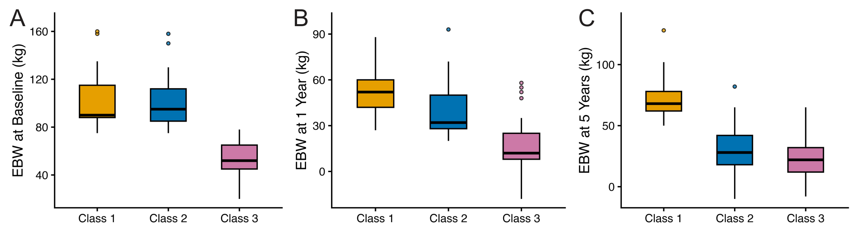
Supplementary Figure 1. Excess body weight distributions across latent trajectory classes.
a. EBW at baseline, b. EBW at 1 year, and c. EBW at 5 years post-surgery for Classes 1 (gold), 2 (blue), and 3 (pink) identified by latent class growth mixture modeling. Class 3 had substantially lower baseline EBW and was excluded from metabolomic analysis.
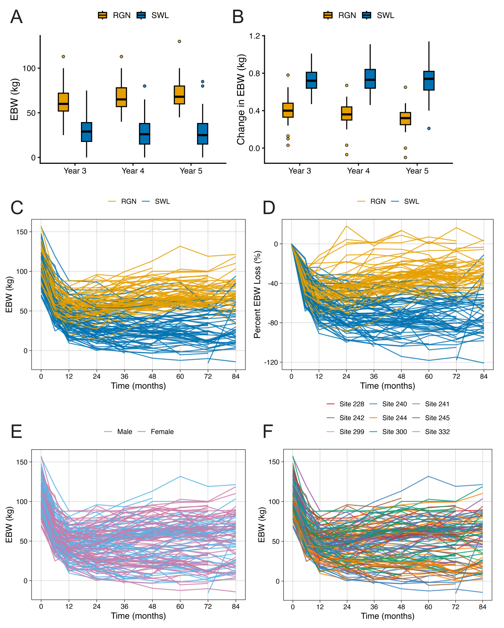
Supplementary Figure 2. Weight trajectories by outcome group, sex, and surgical site.
a. EBW (kg) at years 3, 4, and 5 for weight regain (RGN) and sustained weight loss (SWL) groups. b. Change in EBW (kg) at years 3, 4, and 5 by outcome group. c. Individual EBW trajectories over 84 months colored by outcome group (RGN, gold; SWL, blue). d. Percent EBW loss over 84 months by outcome group. e. Individual EBW trajectories by sex (male, blue; female, pink). f. Individual EBW trajectories colored by surgical site.
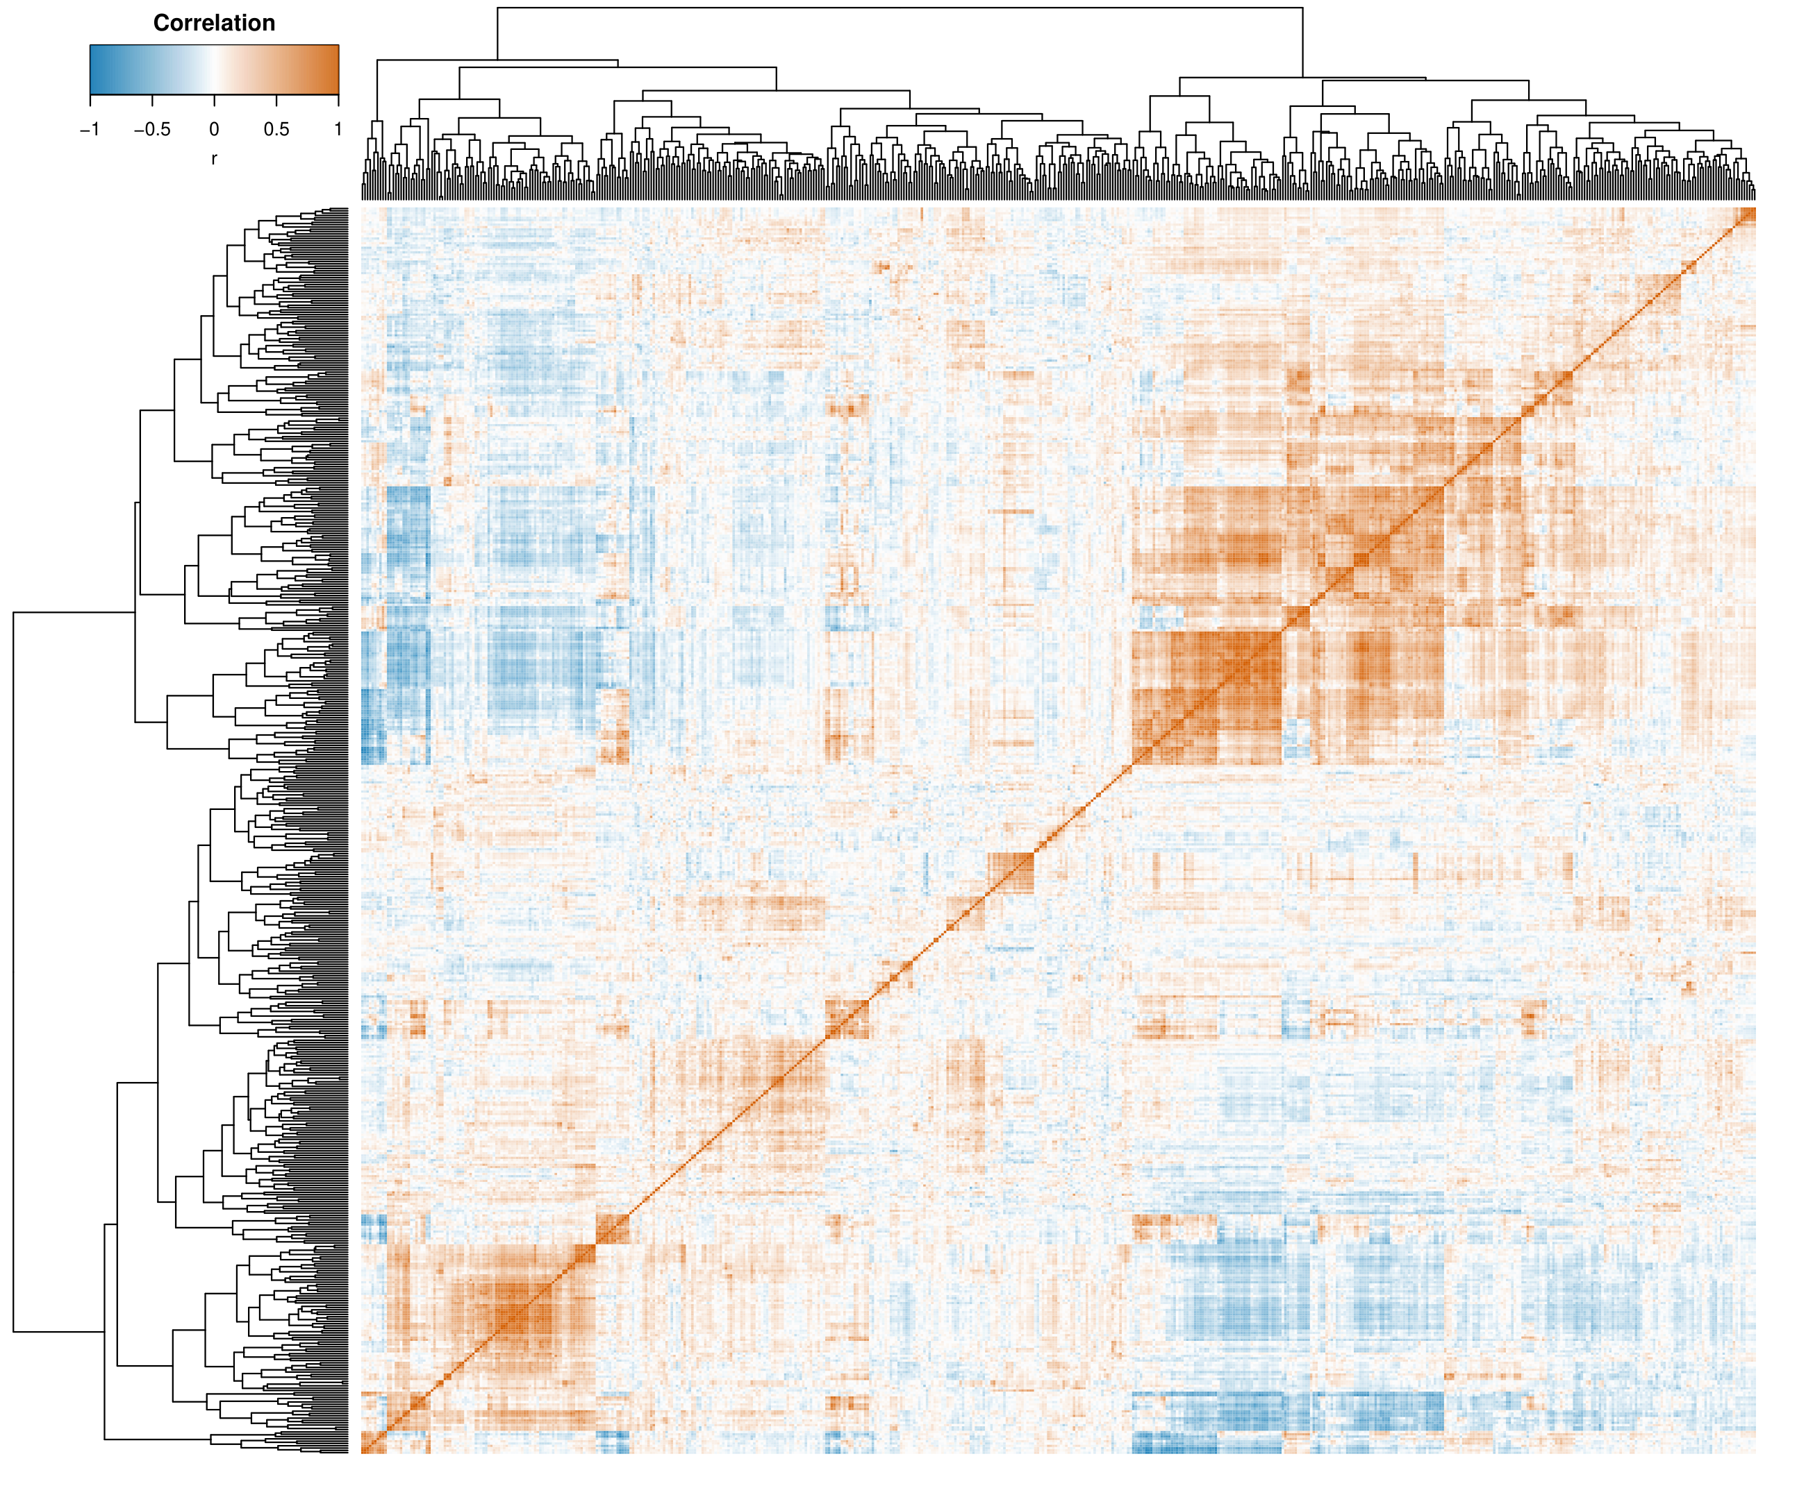
Supplementary Figure 3. Pairwise metabolite correlation matrix.
Heatmap of Pearson correlation coefficients among all metabolites included in the analysis. Color scale ranges from -1 (blue) to 1 (red).
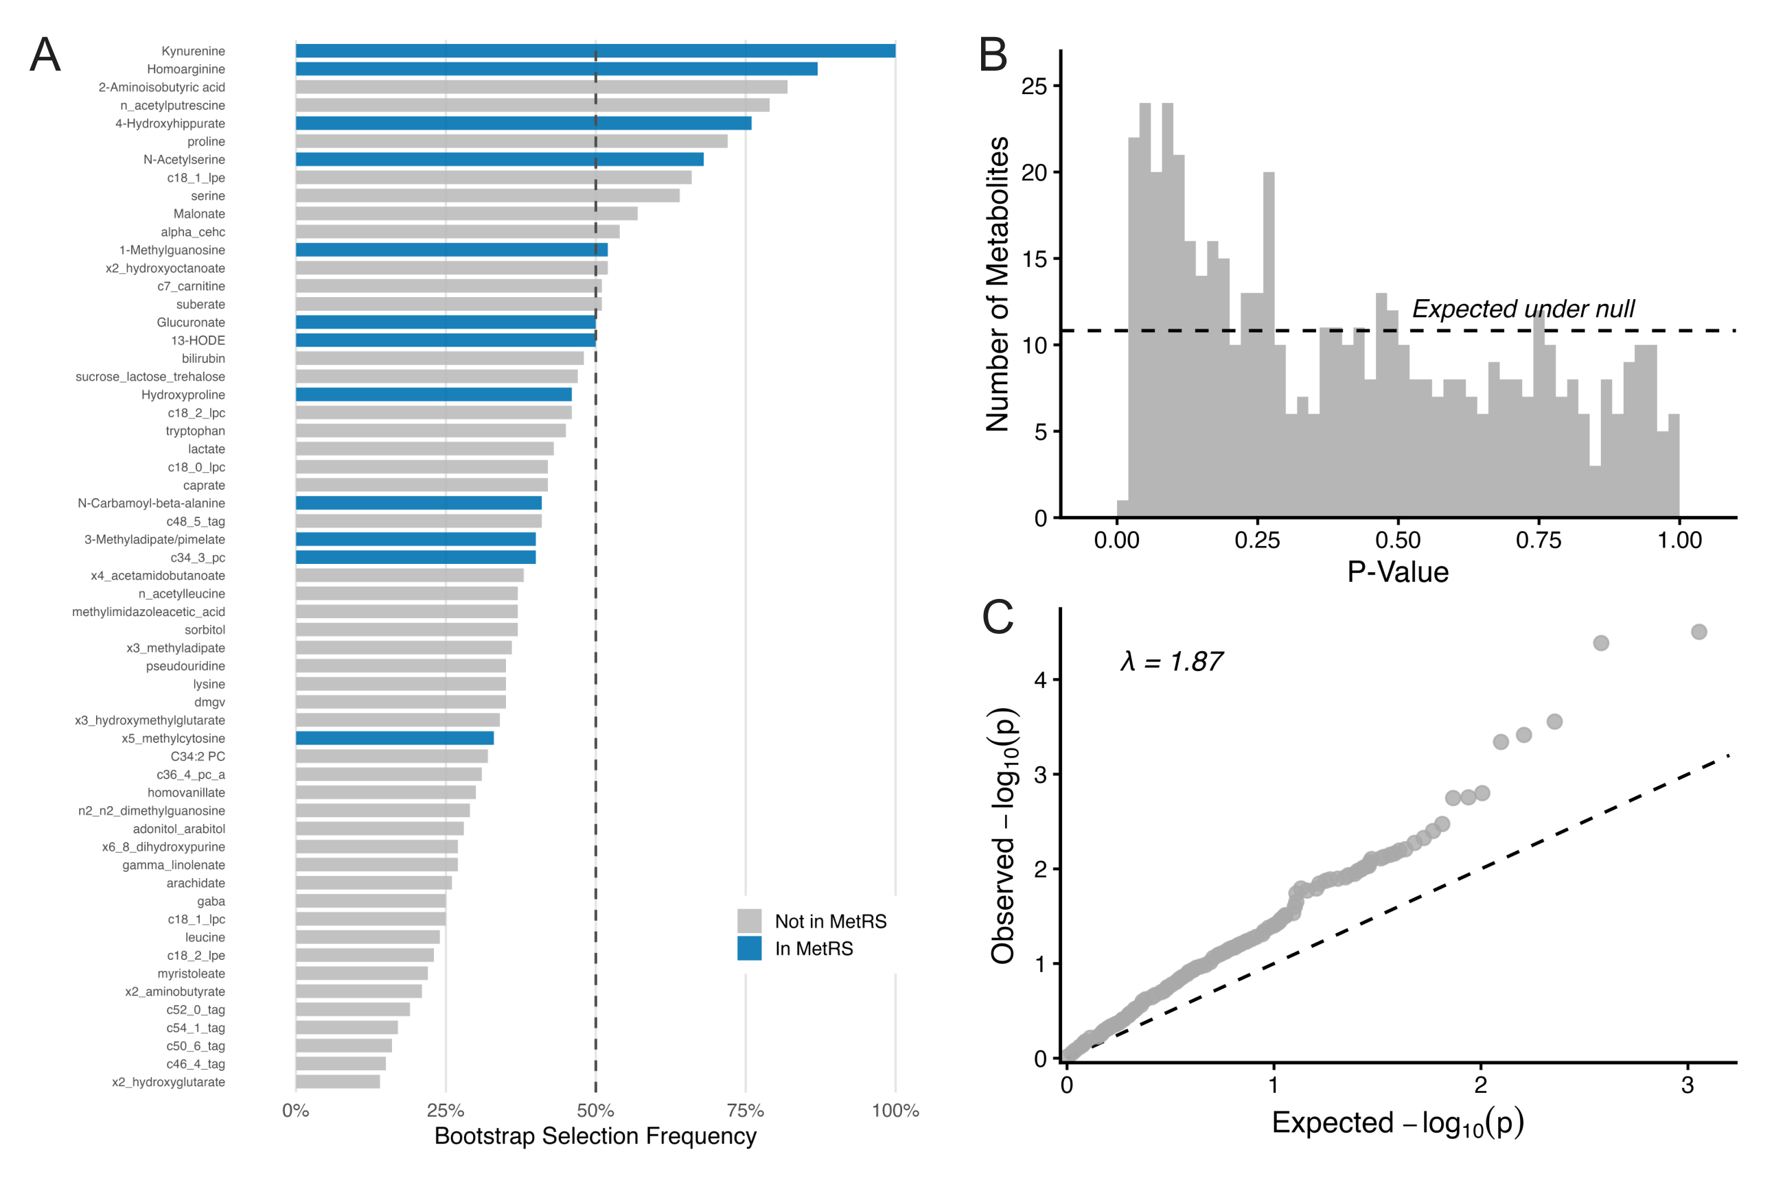
Supplementary Figure 4. Metabolite selection stability and association distribution.
a. Bootstrap selection frequency for candidate metabolites across 1,000 iterations of bidirectional stepwise regression. Blue bars indicate metabolites included in the final MetRS; gray bars indicate metabolites not retained. Dashed line marks the 50% selection threshold. b. Histogram of p-values from univariate associations between all 541 metabolites and %EBW5. Dashed line indicates the expected number of metabolites under the null distribution. c. Quantile-quantile (Q-Q) plot of observed versus expected -log₁₀(p) values (genomic inflation factor λ = 1.87).
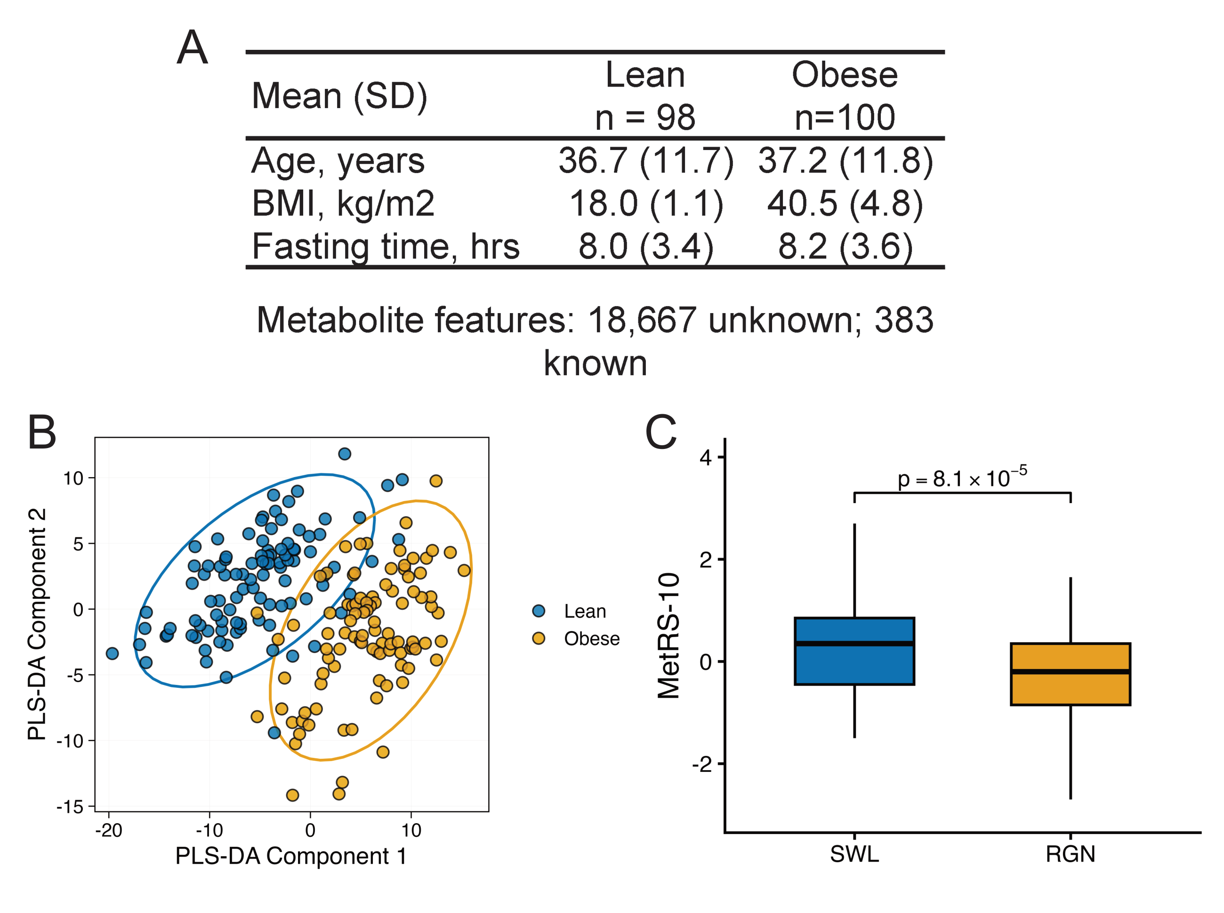
Supplementary Figure 5. External evaluation in the Estonian Biobank obesity extremes cohort.
a. Demographic and clinical characteristics of lean (n = 98) and obese (n = 100) participants. Metabolite features: 18,667 unknown; 383 known. b. Partial least squares discriminant analysis (PLS-DA) of lean (blue) and obese (gold) participants based on metabolomic profiles. c. MetRS-10 in the discovery cohort comparing sustained weight loss (SWL) and weight regain (RGN) groups (p = 8.1 × 10⁻⁵), confirming discriminative ability of the reduced score.
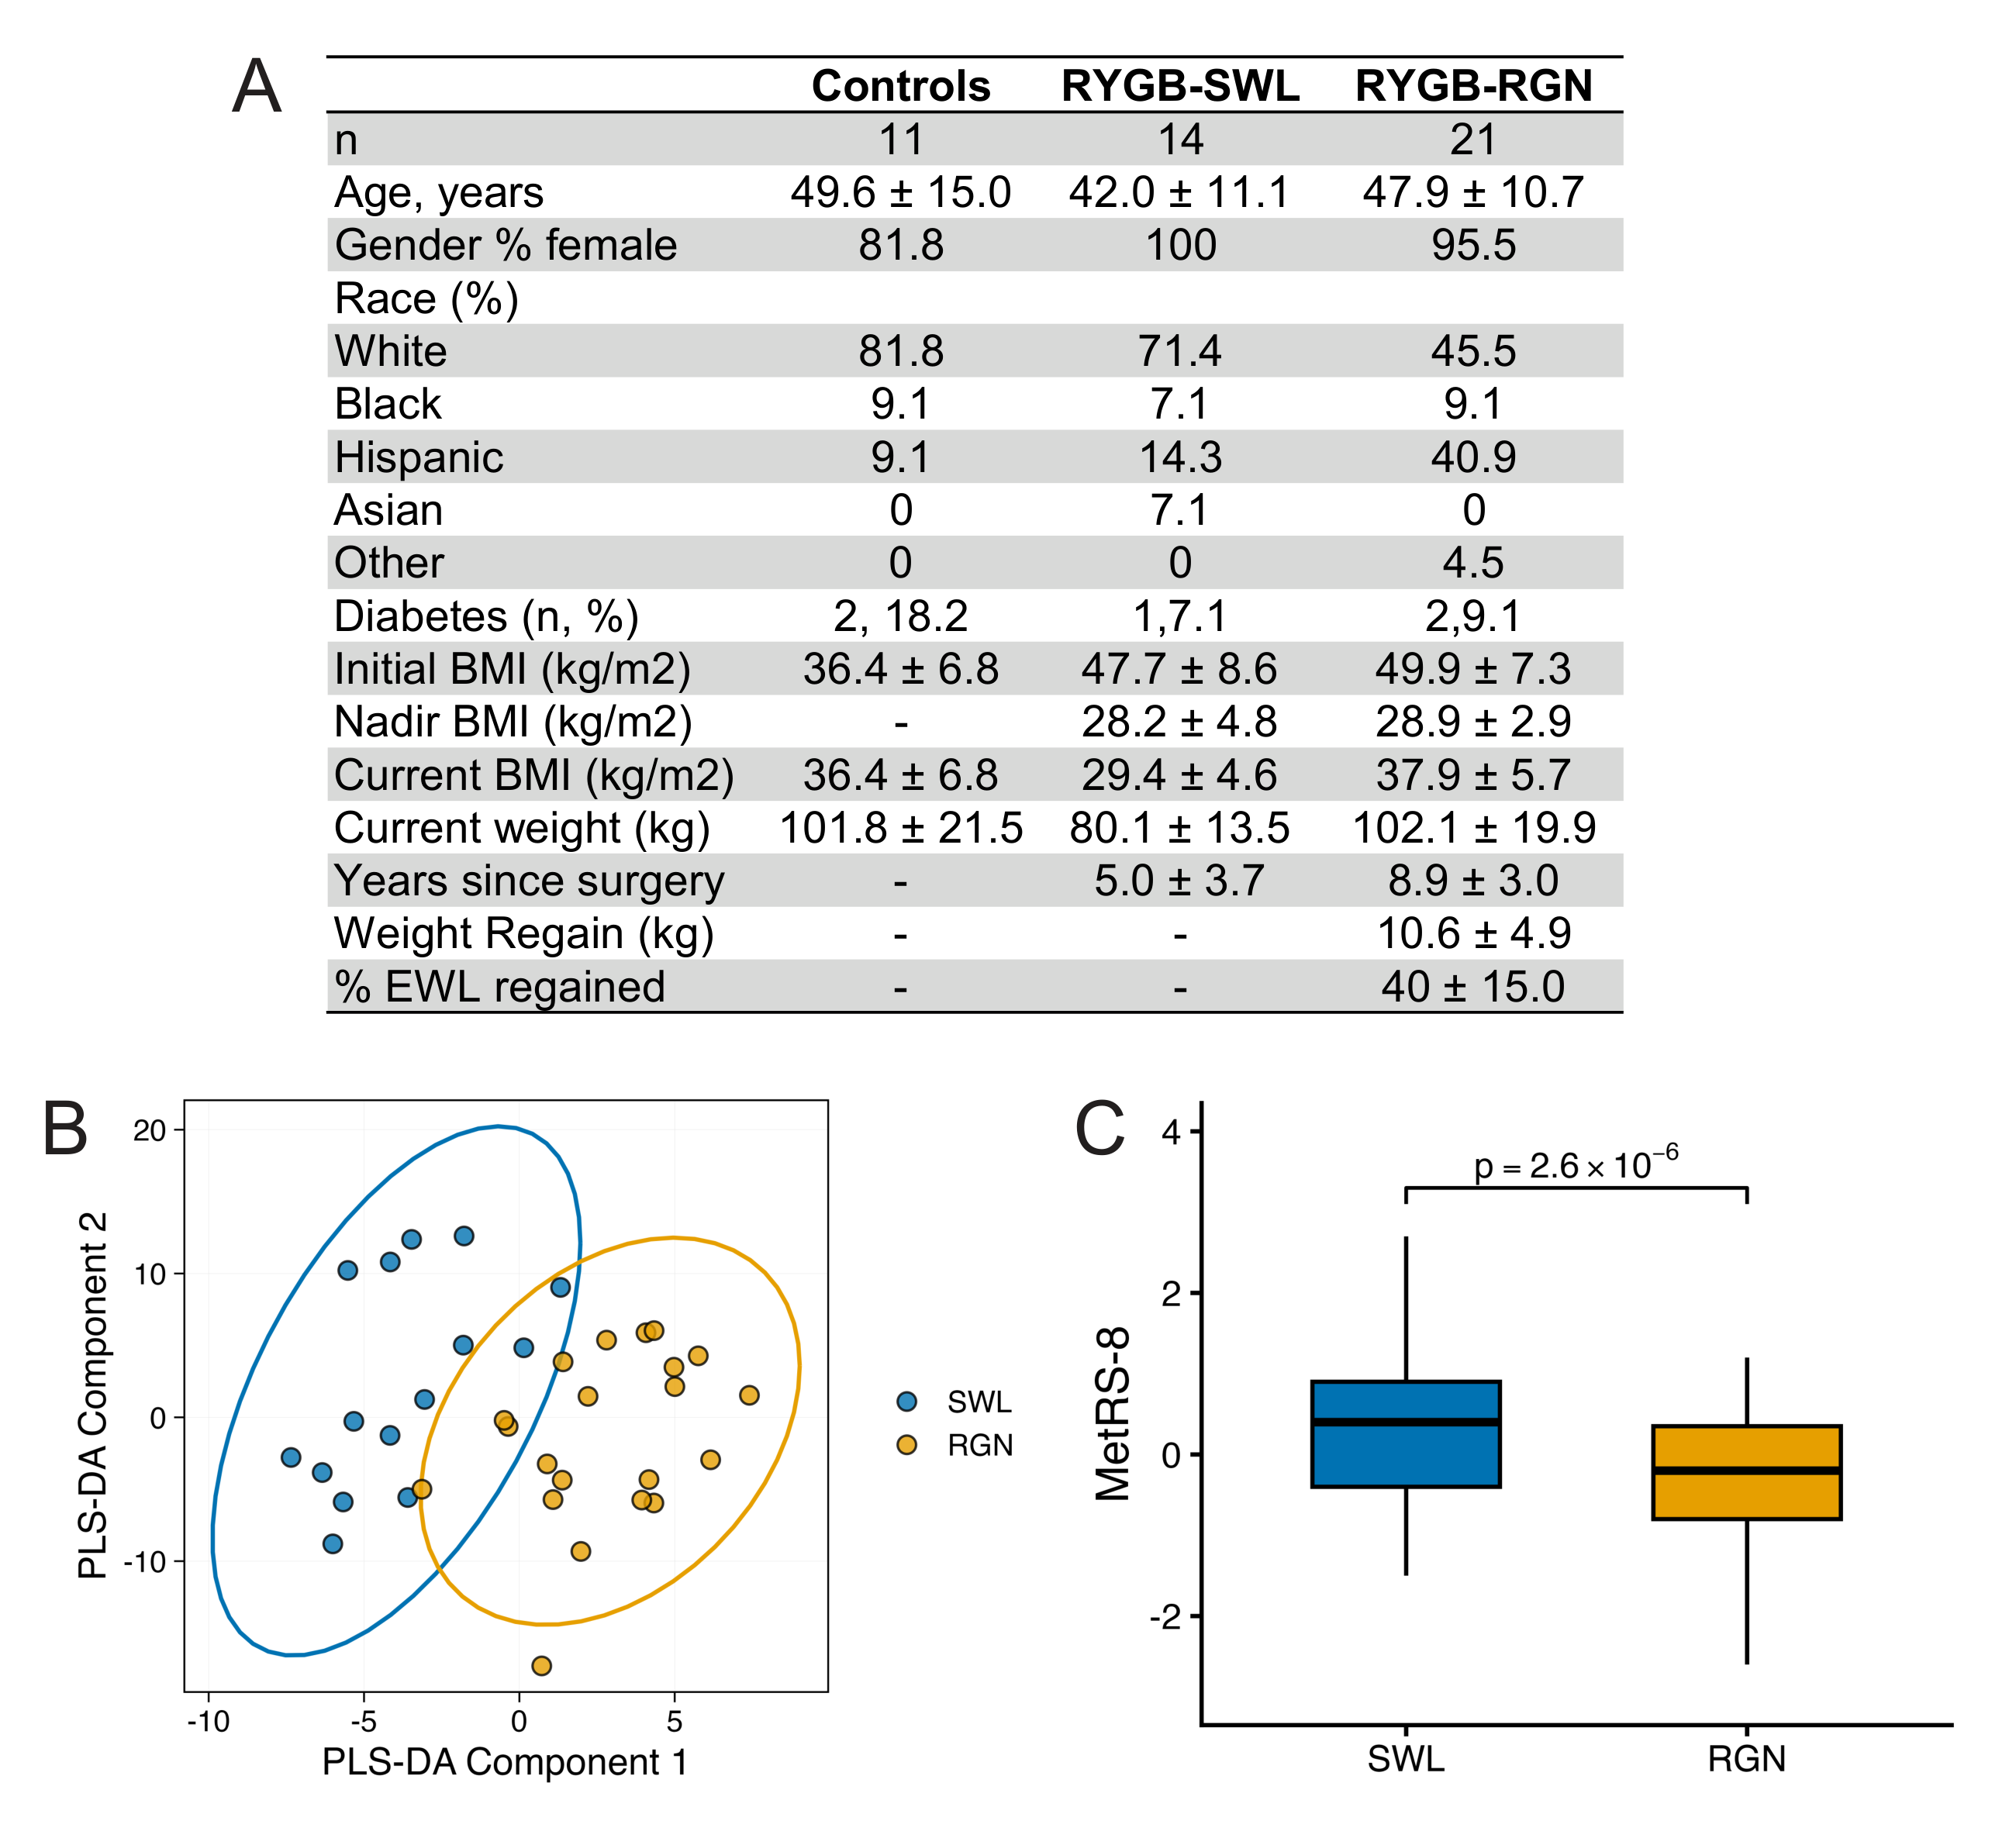
Supplementary Figure 6. External evaluation in an independent post-RYGB clinical cohort.
a. Demographic and clinical characteristics of controls (n = 11), RYGB with sustained weight loss (RYGB-SWL, n = 14), and RYGB with weight regain (RYGB-RGN, n = 21). b. PLS-DA of SWL (blue) and RGN (gold) participants based on metabolomic profiles. c. MetRS-8 in the discovery cohort comparing SWL and RGN groups (p = 2.6 × 10⁻⁶), confirming discriminative ability of the reduced score.
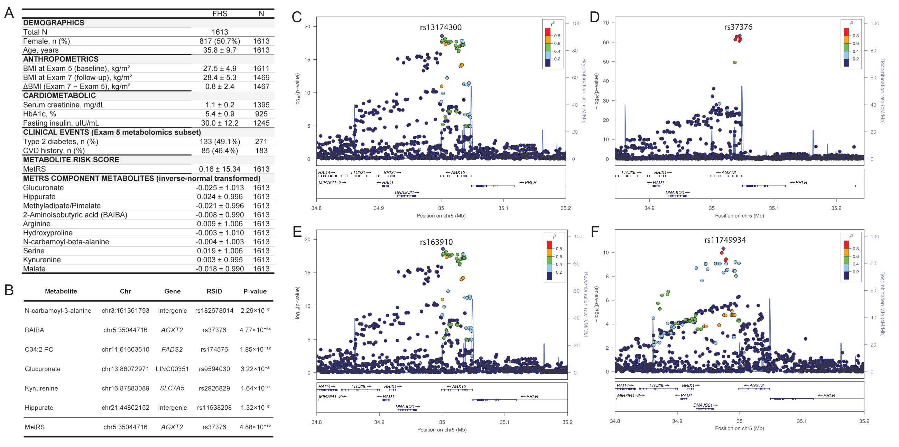
Supplementary Figure 7. Genetic architecture of MetRS and constituent metabolites in the Framingham Heart Study.
a. Demographic, anthropometric, cardiometabolic, and metabolite characteristics of the FHS Offspring cohort (n = 1,613). b. Genome-wide significant loci for MetRS component metabolites, including chromosomal position, gene, rsID, and p-value. c. Regional association plot at the AGXT2 locus (chr5) for the MetRS-associated variant rs13174300. d. Regional association plot at AGXT2 for the BAIBA-associated variant rs37376 (primary signal). e. Regional association plot at AGXT2 for the BAIBA-associated variant rs163910 (secondary signal, conditioned on rs37376). f. Regional association plot at AGXT2 for the BAIBA-associated variant rs11749934 (tertiary signal, conditioned on rs37376 and rs163910).

